**Supplemental Material**

**Table S1**

*A summary of driving behaviors examined in this study.*

|  |  |
| --- | --- |
| **Measure** | **Definition** |
| Number of Days Driving | Total number of days in a month with at least one trip (a trip is a non-zero distance between vehicle engine-on to engine off) |
| Total Miles | Total miles driven in a month |
| Total Trips | Total number of trips in a month |
| Total Trip Minutes | Total minutes of driving in month |
| Total Trip Chains | Number of trip chains in a month (a chain is a series of trips starting and ending at home) |
| Miles Per Trip | Total miles driven in month divided by total number of trips in month |
| Minutes Per Trip | Total minutes of driving in a month divided by total number of trips in month |
| Miles Per Chain | Total miles driven in month divided by total number of trip chains in month |
| Minutes Per Chain | Total minutes of driving in a month divided by total number of trip chains in month |
| Travel Speed (MPH) | Total miles driven in a month divided by total trip minutes of driving in a month times 60. This measure was derived and not included in the original LongROAD data. |
| Number of Left Turns | Number of left turns in a month |
| Right to Left Turn Ratio | Ratio of all right-hand to left-hand turns in a month |
| Number of Trips AM Rush Hour | Number of trips in a month taken between 7 - 9 AM on weekdays |
| Percentage of Trips AM Rush Hour | Percentage of trips taken in month between 7 - 9 AM on weekdays |
| Number of Trips PM Rush Hour | Number of trips taken in a month during 4 - 6 PM on weekdays |
| Percentage of Trips PM Rush Hour | Percentage of trips taken in a month between 4 - 6 PM on weekdays |
| Number of Trips at Night | Number of trips during which at least 80% of the trip was during nighttime (solar angle>96) in a month |
| Percentage of Trips at Night | Percentage of trips of which at least 80% of the trip was during nighttime (solar angle>96) in a month |
| Number of Trips < 15 Miles | Number of trips traveled within 15 miles of residence in a month |
| Percentage of Trips < 15 Miles | Miles traveled within 15 miles of residence divided by total miles driven in month |
| Number of Trips > 60 MPH | Number of trips in a month traveled where 20 percent of distance travelled was at speeds of 60 miles per hour or higher |
| Percentage of Trips > 60 MPH | Percentage of trips in a month traveled where 20 percent of distance travelled was at speeds of 60 miles per hour or higher |
| Speeding Events Per 1000 Miles | Number of speeding events per 1000 miles (speed >80 miles/hr sustained for at least 8 seconds) |
| Hard-Braking Events Per 1000 Miles | Number of sudden decelerations (>0.4 g) per 1000 miles |

**Figure S1**

*Distributions of driving variables.*

*Note.* Means are indicated by the red dashed lines.

**Figure S2**

*Correlation matrix of driving variables.*

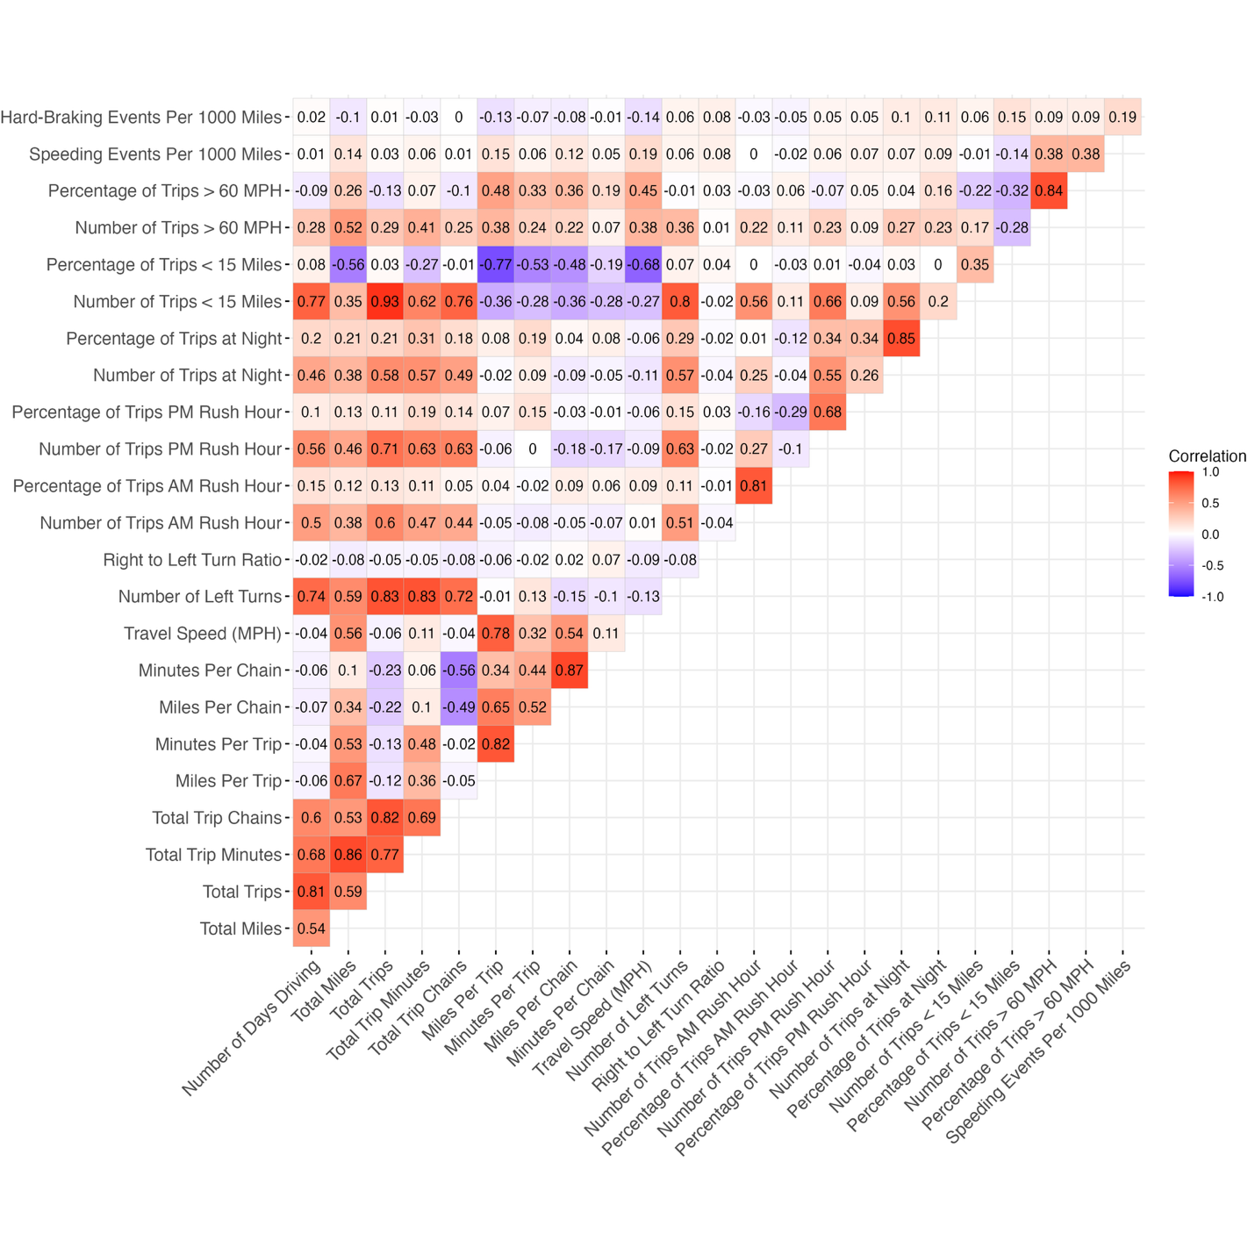

|  |  |  |  |  |  |  |
| --- | --- | --- | --- | --- | --- | --- |
| **Table S3**  *Significant multivariate analysis results comparing a candidate relationship (IV and Candidate DV) against other relationships with the same driving variable (IV and Against DV)* | | | | | | |
| IV | Candidate DV | Against DV | Coefficient | 95% CI | *z* | *p* |
| Travel Speed (MPH) | Physical Decline | Low Informational Support | -0.109 | [-0.169, -0.049] | -3.561 | 0.0037 |
| Travel Speed (MPH) | Physical Decline | Low Instrumental Support | -0.099 | [-0.157, -0.04] | -3.294 | 0.0099 |
| Travel Speed (MPH) | Physical Decline | Low Emotional Support | -0.086 | [-0.145, -0.028] | -2.888 | 0.0388 |
|  |  |  |  |  |  |  |
| Number of Days Driving | Physical Decline | Cognitive Decline | -0.113 | [-0.159, -0.066] | -4.769 | < .001 |
| Number of Days Driving | Physical Decline | Fatigue | -0.059 | [-0.099, -0.019] | -2.907 | 0.0365 |
| Number of Days Driving | Physical Decline | Anxiety | -0.121 | [-0.169, -0.073] | -4.936 | < .001 |
| Number of Days Driving | Physical Decline | Depression | -0.106 | [-0.153, -0.06] | -4.468 | < .001 |
| Number of Days Driving | Physical Decline | Anger | -0.154 | [-0.202, -0.106] | -6.286 | < .001 |
| Number of Days Driving | Physical Decline | Role Constraints | -0.085 | [-0.125, -0.045] | -4.148 | < .001 |
| Number of Days Driving | Physical Decline | Low Informational Support | -0.083 | [-0.134, -0.033] | -3.226 | 0.0125 |
| Number of Days Driving | Physical Decline | Low Instrumental Support | -0.107 | [-0.157, -0.058] | -4.238 | < .001 |
| Number of Days Driving | Physical Decline | Low Emotional Support | -0.09 | [-0.139, -0.04] | -3.564 | 0.0037 |
|  |  |  |  |  |  |  |
| Number of Left Turns | Physical Decline | Cognitive Decline | -0.079 | [-0.127, -0.031] | -3.24 | 0.012 |
| Number of Left Turns | Physical Decline | Anxiety | -0.076 | [-0.126, -0.026] | -2.996 | 0.0274 |
| Number of Left Turns | Physical Decline | Anger | -0.098 | [-0.148, -0.049] | -3.881 | 0.001 |
|  |  |  |  |  |  |  |
| Total Miles | Social Isolation | Anger | -0.078 | [-0.119, -0.037] | -3.718 | 0.002 |
|  |  |  |  |  |  |  |
| Miles Per Chain | Depression | Physical Decline | -0.09 | [-0.138, -0.042] | -3.665 | 0.0025 |
|  |  |  |  |  |  |  |
| Minutes Per Trip | Physical Decline | Cognitive Decline | 0.144 | [0.096, 0.192] | 5.937 | < .001 |
| Minutes Per Trip | Physical Decline | Fatigue | 0.085 | [0.044, 0.125] | 4.065 | < .001 |
| Minutes Per Trip | Physical Decline | Anxiety | 0.142 | [0.092, 0.191] | 5.626 | < .001 |
| Minutes Per Trip | Physical Decline | Depression | 0.145 | [0.097, 0.193] | 5.965 | < .001 |
| Minutes Per Trip | Physical Decline | Anger | 0.108 | [0.058, 0.157] | 4.276 | < .001 |
| Minutes Per Trip | Physical Decline | Role Constraints | 0.087 | [0.046, 0.128] | 4.153 | < .001 |
| Minutes Per Trip | Physical Decline | Low Informational Support | 0.122 | [0.071, 0.174] | 4.62 | < .001 |
| Minutes Per Trip | Physical Decline | Low Instrumental Support | 0.151 | [0.1, 0.202] | 5.839 | < .001 |
| Minutes Per Trip | Physical Decline | Low Emotional Support | 0.147 | [0.097, 0.198] | 5.703 | < .001 |
| Minutes Per Trip | Physical Decline | Social Isolation | 0.146 | [0.098, 0.194] | 5.934 | < .001 |
|  |  |  |  |  |  |  |
| Miles Per Trip | Anxiety | Physical Decline | -0.085 | [-0.135, -0.034] | -3.251 | 0.0115 |
|  |  |  |  |  |  |  |
| Percentage of Trips AM Rush Hour | Physical Decline | Cognitive Decline | -0.075 | [-0.122, -0.028] | -3.138 | 0.017 |
| Percentage of Trips AM Rush Hour | Physical Decline | Low Informational Support | -0.087 | [-0.138, -0.036] | -3.318 | 0.0091 |
|  |  |  |  |  |  |  |
| Percentage of Trips PM Rush Hour | Role Constraints | Cognitive Decline | 0.098 | [0.057, 0.14] | 4.669 | < .001 |
| Percentage of Trips PM Rush Hour | Role Constraints | Physical Decline | 0.065 | [0.024, 0.105] | 3.096 | 0.0196 |
| Percentage of Trips PM Rush Hour | Role Constraints | Anxiety | 0.071 | [0.03, 0.112] | 3.366 | 0.0076 |
| Percentage of Trips PM Rush Hour | Role Constraints | Depression | 0.092 | [0.05, 0.134] | 4.311 | < .001 |
| Percentage of Trips PM Rush Hour | Role Constraints | Anger | 0.088 | [0.046, 0.129] | 4.17 | < .001 |
| Percentage of Trips PM Rush Hour | Role Constraints | Social Isolation | 0.097 | [0.059, 0.136] | 5.008 | < .001 |
| Percentage of Trips PM Rush Hour | Role Constraints | Low Informational Support | 0.145 | [0.096, 0.194] | 5.832 | < .001 |
| Percentage of Trips PM Rush Hour | Role Constraints | Low Emotional Support | 0.137 | [0.09, 0.184] | 5.718 | < .001 |
| Percentage of Trips PM Rush Hour | Role Constraints | Low Instrumental Support | 0.082 | [0.036, 0.129] | 3.458 | 0.0054 |
|  |  |  |  |  |  |  |
| Total Trip Chains | Physical Decline | Cognitive Decline | -0.1 | [-0.148, -0.052] | -4.1 | < .001 |
| Total Trip Chains | Physical Decline | Fatigue | -0.065 | [-0.105, -0.024] | -3.095 | 0.0197 |
| Total Trip Chains | Physical Decline | Anxiety | -0.089 | [-0.139, -0.04] | -3.538 | 0.004 |
| Total Trip Chains | Physical Decline | Depression | -0.081 | [-0.129, -0.033] | -3.31 | 0.0093 |
| Total Trip Chains | Physical Decline | Anger | -0.113 | [-0.163, -0.064] | -4.484 | < .001 |
| Total Trip Chains | Physical Decline | Role Constraints | -0.077 | [-0.118, -0.036] | -3.647 | 0.0026 |
| Total Trip Chains | Physical Decline | Low Informational Support | -0.077 | [-0.13, -0.025] | -2.911 | 0.036 |
| Total Trip Chains | Physical Decline | Low Instrumental Support | -0.096 | [-0.147, -0.045] | -3.687 | 0.0023 |
| Total Trip Chains | Physical Decline | Low Emotional Support | -0.08 | [-0.131, -0.029] | -3.08 | 0.0207 |
|  |  |  |  |  |  |  |
| Total Trip Minutes | Social Isolation | Anxiety | -0.069 | [-0.11, -0.028] | -3.326 | 0.0088 |
| Total Trip Minutes | Social Isolation | Anger | -0.108 | [-0.148, -0.068] | -5.266 | < .001 |
| Total Trip Minutes | Social Isolation | Role Constraints | -0.08 | [-0.119, -0.041] | -4.037 | < .001 |
|  |  |  |  |  |  |  |
| Total Trips | Physical Decline | Cognitive Decline | -0.117 | [-0.163, -0.07] | -4.922 | < .001 |
| Total Trips | Physical Decline | Fatigue | -0.059 | [-0.099, -0.019] | -2.905 | 0.0367 |
| Total Trips | Physical Decline | Anxiety | -0.121 | [-0.169, -0.073] | -4.925 | < .001 |
| Total Trips | Physical Decline | Depression | -0.094 | [-0.141, -0.047] | -3.95 | < .001 |
| Total Trips | Physical Decline | Anger | -0.142 | [-0.19, -0.094] | -5.789 | < .001 |
| Total Trips | Physical Decline | Role Constraints | -0.09 | [-0.13, -0.05] | -4.379 | < .001 |
| Total Trips | Physical Decline | Low Instrumental Support | -0.099 | [-0.149, -0.05] | -3.921 | < .001 |
| Total Trips | Physical Decline | Low Emotional Support | -0.072 | [-0.122, -0.023] | -2.856 | 0.0429 |
|  |  |  |  |  |  |  |
| Number of Trips AM Rush Hour | Physical Decline | Cognitive Decline | -0.098 | [-0.144, -0.051] | -4.102 | < .001 |
| Number of Trips AM Rush Hour | Physical Decline | Anger | -0.096 | [-0.145, -0.048] | -3.898 | 0.001 |
| Number of Trips AM Rush Hour | Physical Decline | Low Informational Support | -0.08 | [-0.131, -0.029] | -3.059 | 0.0222 |
|  |  |  |  |  |  |  |
| Number of Trips < 15 Miles | Physical Decline | Cognitive Decline | -0.122 | [-0.168, -0.075] | -5.136 | < .001 |
| Number of Trips < 15 Miles | Physical Decline | Anxiety | -0.13 | [-0.178, -0.082] | -5.283 | < .001 |
| Number of Trips < 15 Miles | Physical Decline | Depression | -0.106 | [-0.153, -0.059] | -4.449 | < .001 |
| Number of Trips < 15 Miles | Physical Decline | Anger | -0.147 | [-0.195, -0.099] | -5.992 | < .001 |
| Number of Trips < 15 Miles | Physical Decline | Role Constraints | -0.086 | [-0.126, -0.046] | -4.202 | < .001 |
| Number of Trips < 15 Miles | Physical Decline | Low Instrumental Support | -0.092 | [-0.142, -0.043] | -3.639 | 0.0027 |
|  |  |  |  |  |  |  |
| Minutes Per Chain | Physical Decline | Cognitive Decline | 0.121 | [0.074, 0.167] | 5.055 | < .001 |
| Minutes Per Chain | Physical Decline | Fatigue | 0.096 | [0.056, 0.136] | 4.696 | < .001 |
| Minutes Per Chain | Physical Decline | Anxiety | 0.094 | [0.045, 0.142] | 3.785 | 0.0015 |
| Minutes Per Chain | Physical Decline | Depression | 0.123 | [0.076, 0.17] | 5.14 | < .001 |
| Minutes Per Chain | Physical Decline | Anger | 0.079 | [0.03, 0.128] | 3.178 | 0.0148 |
| Minutes Per Chain | Physical Decline | Role Constraints | 0.087 | [0.047, 0.128] | 4.226 | < .001 |
| Minutes Per Chain | Physical Decline | Low Informational Support | 0.113 | [0.062, 0.164] | 4.333 | < .001 |
| Minutes Per Chain | Physical Decline | Low Instrumental Support | 0.12 | [0.07, 0.17] | 4.72 | < .001 |
| Minutes Per Chain | Physical Decline | Low Emotional Support | 0.115 | [0.065, 0.164] | 4.505 | < .001 |
| Minutes Per Chain | Physical Decline | Social Isolation | 0.089 | [0.041, 0.136] | 3.652 | 0.0026 |

*Note.* *p*-values are adjusted using the Bonferroni method. For each driving variable (IV), the number of significant comparisons should add up to the number of crossed-out tiles in Figure 3A.

**Table S3**

*Bivariate Relationships with Physical Decline with Additional Covariates.*

|  |  |  |  |  |  |
| --- | --- | --- | --- | --- | --- |
| **Predictor** | | ***β*** | **95% CI** | ***t*** | ***p*-values** |
| **Minutes Per Trip** | |  |  |  |  |
|  | Controlling for demographic | 0.102 | [0.063, 0.140] | 5.20 | < .001 |
|  | Controlling for demographic + Miles Per Trip | 0.385 | [0.310, 0.460] | 10.06 | < .001 |
| **Minutes Per Chain** | |  |  |  |  |
|  | Controlling for demographic | 0.073 | [0.035, 0.111] | 3.79 | 0.044 |
|  | Controlling for demographic + Miles Per Chain | 0.309 | [0.225, 0.393] | 7.21 | < .001 |

**Table S4**

*A summary of out-of-sample model prediction performance of full against reduced models.*

| ***DV*** | ***ΔMSE*** | ***t*** | ***df*** | ***Cohen’s d*** | ***p*** |
| --- | --- | --- | --- | --- | --- |
| Physical Decline | -0.060 | -5.055 | 2,657 | -0.098 | < .001 |
| Life Satisfaction | -0.037 | -4.868 | 2,657 | -0.094 | < .001 |
| Role Constraints | -0.021 | -3.136 | 2,657 | -0.061 | 0.010 |
| Fatigue | -0.019 | -2.947 | 2,657 | -0.057 | 0.019 |
| Depression | -0.010 | -2.302 | 2,657 | -0.045 | 0.129 |
| Social Isolation | -0.010 | -1.841 | 2,657 | -0.036 | 0.395 |
| Low Emotional Support | -0.006 | -0.970 | 2,657 | -0.019 | > .99 |
| Anxiety | -0.006 | -1.499 | 2,657 | -0.029 | 0.803 |
| Low Instrumental Support | -0.005 | -0.776 | 2,657 | -0.015 | > .99 |
| Low Informational Support | -0.003 | -0.462 | 2,657 | -0.009 | > .99 |
| Cognitive Decline | 0.002 | 0.472 | 2,657 | 0.009 | > .99 |
| Anger | 0.004 | 0.913 | 2,657 | 0.018 | > .99 |

**Note.** *p*: Bonferroni-adjusted *p*-values.

**Health and well-being questions used in this study**

**Life Satisfaction**

For the next set of questions, please turn to Card 11 and choose the response that best applies to you. Think about your life‐as‐a‐whole. How satisfied are you with it ‐, with the responses being completely satisfied, very satisfied, somewhat satisfied, not very satisfied, or not at all satisfied.

Please think about your life and situation right now.

|  |  |  |  |  |
| --- | --- | --- | --- | --- |
| (1) Not at all satisfied | (2) Not very satisfied | (3) Somewhat satisfied | (4) Very satisfied | (5) Completely satisfied |

1. How satisfied are you with: Your daily life and leisure activities?
2. How satisfied are you with: Your family life?
3. How satisfied are you with: Your present financial situation?
4. How satisfied are you with: The total income of your household?
5. How satisfied are you with: Your health?

**Cognitive Decline (PROMIS SF v1.0-Applied Cognition-General Concerns 4a)**

For each statement, please choose the response that best applies to you, with the responses being never, rarely, sometimes, often, or very often.

|  |  |  |  |  |
| --- | --- | --- | --- | --- |
| (1) Never | (2) Rarely | (3) Sometimes | (4) Often | (5) Very often |

1. In the past 7 days, my thinking has been slow
2. In the past 7 days, it seemed like my brain was not working as well as usual
3. In the past 7 days, I have had to work harder than usual to keep track of what I was doing
4. In the past 7 days, I have had trouble shifting back and forth between different activities that require thinking

**Physical Decline (PROMIS SF v1.0-Physical Function 4a)**

We need to understand the difficulties that people might have with various activities because of health or physical problems.   For the next set of questions, please turn to Card 13 and choose the response that best applies to you, with the responses being: without any difficulty, with a little difficulty, with some difficulty, with much difficulty, or unable to do.

|  |  |  |  |  |
| --- | --- | --- | --- | --- |
| (1) Without any difficulty | (2) With a little difficulty | (3) With some difficulty | (4) With much difficulty | (5) Unable to do |

1. Are you able to do chores such as vacuuming or yard work?
2. Are you able to go up and down stairs at a normal pace?
3. Are you able to go for a walk of at least 15 minutes?
4. Are you able to run errands and shop?

**Fatigue (PROMIS SF v1.0-Fatigue 4a)**

Please turn to Card 14 and choose the response that best applies to you, with the responses being not at all, a little bit, somewhat, quite a bit, or very much

|  |  |  |  |  |
| --- | --- | --- | --- | --- |
| (1) Not at all | (2) A little bit | (3) Somewhat | (4) Quite a bit | (5) Very much |

1. In the past 7 days, I felt fatigued
2. In the past 7 days, I had trouble starting things because I am too tired
3. In the past 7 days, how run-down did you feel on average?
4. In the past 7 days, how fatigued were you on average?

**Role Constraints (PROMIS SF v2.0-Ability to Part. in Social Roles/Acts 4a)**

Please turn to Card 9, and choose the response that best applies to you.

|  |  |  |  |  |
| --- | --- | --- | --- | --- |
| (1) Never | (2) Rarely | (3) Sometimes | (4) Often/Usually | (5) Always |

1. I have trouble doing all of my regular leisure activities with others
2. I have trouble doing all of the family activities that I want to do
3. I have trouble doing all of my usual work (include work at home)
4. I have trouble doing all of the activities with friends that I want to do

**Social Isolation (PROMIS SF v2.0-Social Isolation 4a)**

Please turn to Card 9, and choose the response that best applies to you.

|  |  |  |  |  |
| --- | --- | --- | --- | --- |
| (1) Never | (2) Rarely | (3) Sometimes | (4) Often/Usually | (5) Always |

1. I feel left out
2. I feel that people barely know me
3. I feel isolated from others
4. I feel that people are around me but not with me

**Informational Support (PROMIS SF v2.0-Informational Support 4a)**

Please turn to Card 9, and choose the response that best applies to you.

|  |  |  |  |  |
| --- | --- | --- | --- | --- |
| (1) Never | (2) Rarely | (3) Sometimes | (4) Usually | (5) Always |

1. I have someone to give me good advice about a crisis if I need it
2. I have someone to turn to for suggestions about how to deal with a problem
3. I have someone to give me information if I need it
4. I get useful advice about important things in life

**Emotional Support (PROMIS SF v2.0-Emotional Support 4a)**

Please turn to Card 9, and choose the response that best applies to you.

|  |  |  |  |  |
| --- | --- | --- | --- | --- |
| (1) Never | (2) Rarely | (3) Sometimes | (4) Usually | (5) Always |

1. I have someone who will listen to me when I need to talk
2. I have someone to confide in or talk to about myself or my problems
3. I have someone who makes me feel appreciated
4. I have someone to talk with when I have a bad day

**Instrumental Support (PROMIS SF v2.0-Instrumental Support 4a)**

Please turn to Card 9, and choose the response that best applies to you.

|  |  |  |  |  |
| --- | --- | --- | --- | --- |
| (1) Never | (2) Rarely | (3) Sometimes | (4) Often/Usually | (5) Always |

1. Do you have someone to help you if you are confined to bed
2. Do you have someone to take you to the doctor if you need it?
3. Do you have someone to help with your daily chores if you are sick?
4. Do you have someone to run errands if you need it?

**Depression (PROMIS SF v1.0-Depression 4a)**

For each statement, please turn to Card 8 and choose the response that best applies to you, with the responses being: never, rarely, sometimes, often, or always.

|  |  |  |  |  |
| --- | --- | --- | --- | --- |
| (1) Never | (2) Rarely | (3) Sometimes | (4) Often/Usually | (5) Always |

1. In the past 7 days, I felt worthless
2. In the past 7 days, I felt helpless
3. In the past 7 days, I felt depressed
4. In the past 7 days, I felt hopeless

**Anxiety (PROMIS SF v1.0-Anxiety 4a)**

For each statement, please turn to Card 8 and choose the response that best applies to you, with the responses being: never, rarely, sometimes, often, or always.

|  |  |  |  |  |
| --- | --- | --- | --- | --- |
| (1) Never | (2) Rarely | (3) Sometimes | (4) Often/Usually | (5) Always |

1. In the past 7 days, I felt fearful
2. In the past 7 days, I found it hard to focus on anything other than my anxiety
3. In the past 7 days, my worries overwhelmed me
4. In the past 7 days, I felt uneasy

**Anger (PROMIS SF v1.1-Anger 5a)**

For each statement, please turn to Card 8 and choose the response that best applies to you, with the responses being: never, rarely, sometimes, often, or always.

|  |  |  |  |  |
| --- | --- | --- | --- | --- |
| (1) Never | (2) Rarely | (3) Sometimes | (4) Often/Usually | (5) Always |

1. In the past 7 days, I was irritated more than people knew
2. In the past 7 days, I felt angry
3. In the past 7 days, I felt like I was ready to explode
4. In the past 7 days, I was grouchy
5. In the past 7 days, I felt annoyed